***The User’s Guide to Recyclotron***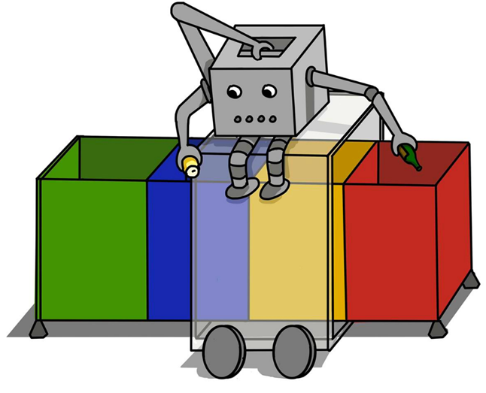

*1. Introducing Recyclotron*

Recylotron is a smart-bin designed to increase the ease and frequency of recycling. As a smart-bin, it detects, sorts and categorises the user’s rubbish for them.

This user guide will help you setup, operate and maintain Recyclotron so you get the best out of it.

On the ground are 4 bins, each a different category of recycling. Each bin has a container, from which the bin can slide out of.

Lining the top perimeter of the 4 bins are a pair of railings joined together to make a frame.

Inside the railings are gaps where gear racks (or teeth) fit. These lock into four gears (or wheels) on the bottom of a box, which we call Recyclotron’s “car”.

See Section 3, Car Description, for more detail on the components of the car.

Figure 1 and Figure 2 show the car on top of the bins and containers, and Figure 3 shows the joined end of the railings.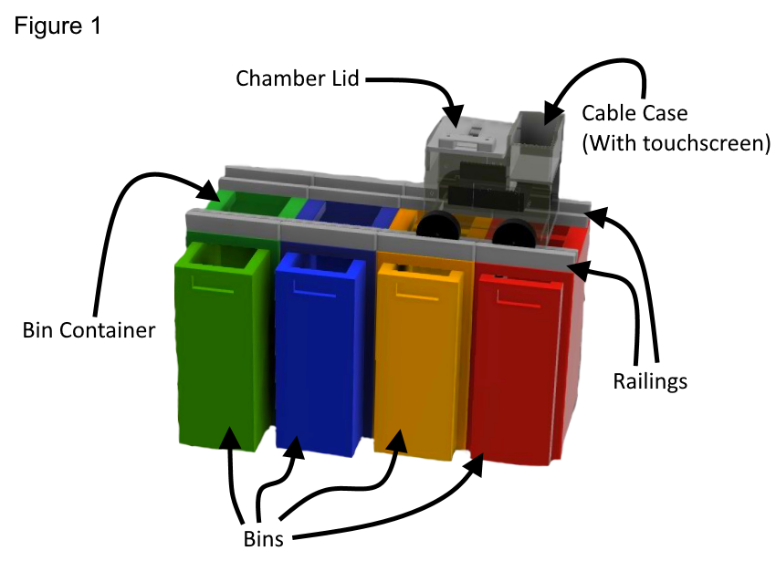

*2. Installation/Setup:*

We supply:

* 1 Recyclotron, the “car”
* A joined frame of 2 railings*
* 4 containers each with a bin that slides out

You will need to provide:

* Access to a power socket
* (Optional) A stable connection to the internet

*In figures 1 & 2 you see two separate railings, but in reality these are joined together in a frame as seen in figure 3.

Setting Up Recyclotron:

1. Place 4 bins alongside each other in a row, packed together as close as possible.*
2. Set the railing frame flat on top of the bins perimeter.**
3. Put Recyclotron’s car on gear racks in railings.
4. Plug in Recyclotron to power and switch on.
5. The startup script will run automatically until completion.
6. Wait until the touchscreen displays system is ready for use.
7. Confirm whether Recyclotron should operate in Online or Offline Mode. (see figure 4)

*From left to right, the bins must be in this order: non-recyclable, other recyclable (plastic), metals and cardboard.

**The pair railings do not attach onto the bins and must lie balanced on top.





Offline Mode:

Recyclotron still operates and sorts objects while offline, albeit taking longer.   
  
While online it takes ~1 minute to sort an object, whereas when offline sorting can take up to 3 minutes.

Switching to/from Offline Mode:

1. Switch power off.
2. Switch power on.
3. Select desired mode when prompt appears. (see figure 4)



*2. Using Recyclotron:*

When the user wants to dispose of their trash they need to do the following steps:

1. Open the lid (see figure 2).
2. Place a single trash object into the chamber (see figure 3).*
3. Close the lid. **
4. The touchscreen displays the category of the trash (see figures 4 & 5).
5. The user has two options:
   1. Wait and allow the default choice go ahead.***
   2. Touch another category on the touchscreen to sort the object into.****
6. The car moves over the rails to the corresponding bin (see figure 10).
7. The trash is dropped into the category's bin.
8. The touchscreen states that Recyclotron is ready for another object from the user.

*If the lid does not close fully, crush, squash or crumple the object. If the lid still does not close, or the object cannot be crushed, the object must be disposed elsewhere.

**Once an object is put inside and the lid is closed, the lid cannot be re-opened until that object is dropped into the bin. This is for both the user’s safety and correct sorting of that object.

***If Recyclotron is confident of its choice, it waits 5 seconds before automatically sorting it. Whereas if uncertain, Recyclotron waits 10 seconds before sorting the object as non-recyclable.

****If the user is uncertain themselves, they should not touch any category as all future sorting of that object will be affected, including mistakes.





*3. Car Description:*

The “car” is a hollow box with 4 walls, a lid on top and no firm floor on the bottom.

Instead of a floor, there is a raised, flat platform we call the “sliding trapdoor”, which moves underneath the back wall.

(the blue wall See figure 6)

We call the space, in between the “sliding trapdoor” and the lid, the “chamber”. This is where rubbish is placed before sorting.

(See figure 7)

Above the “trapdoor” is the lid, and

in the middle of it is a webcam used for analysing the trash.

Opposite the lid’s hinges are two electromagnets used to lock the lid, an electromagnetic sensor called the “lid trigger” that detects when the lid is closed.

(See figure 7)

Beside the lid there is a walled space for cables and hardware, known as the “cable case”.

Inside the “cable case” is a touchscreen used for displaying information to the user.

(See figure 6).

At the back is an ultrasonic sensor which faces a small wall at one end of the railings.

(See figure 6).





*4. Maintaining Recyclotron:*

Recyclotron requires minimal maintenance. As long as it is connected to main power it will remain operational.   
The bins require emptying and if messy rubbish is put inside, the trapdoor will need cleaned.

Cleaning the Trapdoor:

If wet or messy rubbish is put inside the trapdoor will require cleaning in order for objects to sorted successfully sorted.

1. Switch power off and unplug Recyclotron from the socket.
2. Remove the car from the rails and set it down somewhere flat.
3. Open the lid and reach inside to wipe the trapdoor down with a dry cloth.

Emptying Bins:

When a bin is full you will need to empty the bin before adding any more objects.

1. Remove the bin(s) from the container by pulling towards you from the handle. (See figure 8).
2. Remove the bin bag and wipe the bin clean.
3. Add a new bin bag and push the bin back inside its container.
4. Confirm on the touchscreen the bin has been emptied. (See figure 9)



If bins cannot be removed from their containers by pulling, you must do this instead:

1. Switch power off and unplug Recyclotron from the socket.
2. Remove the car from the rails and set it down somewhere flat.
3. Lift the railings off of the bins and set them down somewhere flat.
4. Lift bin and bin bag out. Replace with a new bin bag.
5. Put bin back, set railings upon them and the car back on rails.
6. Plug car back in and switch Recyclotron back on.



1. *Troubleshooting Guide:*

|  |  |  |
| --- | --- | --- |
| Problem | Cause | Solution |
| Lid does not close | Object is too large to fit | Crush or squash object to fit |
| Sorting of item takes longer than 3 minutes | No internet connection | Switch Recyclotron into offline mode, if already in offline mode then restart |
| Touch screen does not respond to input | Unknown | Restart Recyclotron by switching power on and off again |
| Car doesn’t move after putting rubbish in | Lid not closed | Close the lid and wait for touchscreen’s prompt |
| Can’t remove bin from container | Bin is too full to fit or heavy to slide out | Unplug Recyclotron and empty bins as per second method |
| Recyclotron does not start or work at all | No power to Recyclotron | Ensure Recylotron is plugged in and power socket is switched on |